**DAY 2 ASSIGNMENT - 2**

**Waterfall Model (Traditional Methodology)**

The Waterfall model is a linear and step-by-step approach to software development. Each phase must be completed before moving to the next one.

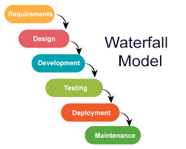

* **Development Flow:** Sequential → One phase must be completed before the next begins.
* **Phases:**
  1. Requirements
  2. Design
  3. Implementation
  4. Testing
  5. Deployment
  6. Maintenance
* **Change Handling:** Difficult. Changes are costly and usually not allowed once development starts.
* **Testing:** Happens after development is complete.
* **Documentation:** Heavy documentation required at each stage.
* **Delivery:** Final product is delivered at the end of the project.
* **Use Case:** Suitable for small projects with well-defined requirements.

**Agile Model (Modern Methodology)**

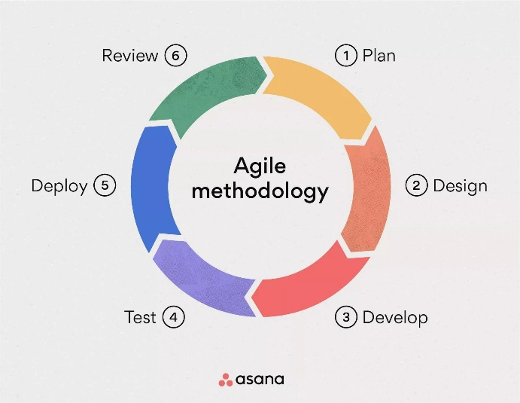

The Agile model is an iterative and flexible approach to software development.

* **Development Flow:** Iterative & Incremental → Work is done in short cycles called sprints (usually 1–4 weeks).
* **Phases per Sprint:**
  1. Plan
  2. Design
  3. Develop
  4. Test
  5. Review
  6. Deploy
* **Change Handling:** Very flexible. Requirements can change at any time.
* **Testing:** Continuous testing within each sprint.
* **Documentation:** Minimal; focuses more on working software.
* **Delivery:** Working features are delivered frequently (at the end of each sprint).
* **Use Case:** Best for large, complex, or evolving projects.